主题：age distribution 年龄分布

题型：静态柱状图

The charts below compare the age structure of the populations of France and India in 1984.

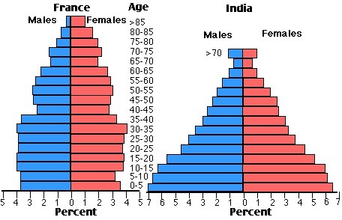

满分范文：

The two charts compare the populations of France and India in terms of age distribution by gender in the year 1984.

It is clear that the population of India was younger than that of France in 1984, with a noticeably larger proportion of people aged under 20. France, on the other hand, had a significantly larger percentage of elderly inhabitants.

In India, close to 14% of people were aged 5 or under, and each five-year age bracket above this contained an increasingly smaller proportion of the population. France’s population, by contrast, was more evenly distributed across the age ranges, with similar figures (around 7% to 8% of all people) for each five-year cohort between the ages of 0 and 40. Somewhere between 10% and 15% of all French people were aged 70 or older, but the equivalent figure for India was only 2%.

Looking more closely at gender, there was a noticeably higher proportion of French women than men in every cohort from age 50 upwards. For example, almost 3% of French 70- to 75-year-olds were women, while just under 2% were men. No significant gender differences can be seen on the Indian population chart.